Effects of COVID-19 Lockdown Measures on Mental Health

**Team Members: Team Awesome!**

* Kristina Ruhl
* Adela Garza
* Leo Zambrano
* Giam Sigaud

**Project Descriptions / Outline**

Team Awesome! will analyze anxiety and depression levels based on state COVID-19 lockdown restriction approaches. We will choose sample states based on COVID-19 “openness” score quartile groupings. We will establish baselines on Kristina stuff & anxiety and depression levels. We will evaluate stress factors such as unemployment levels and CDC factors.

**Research Questions to Answer**

Primary Hypothesis: Did states with more restrictive lockdown measures experienced higher levels of anxiety and depression?

To find out the answer, we looked at 3 things:

1. Openness
2. Anxiety Levels
3. Covid Cases

Supporting Question: 1. How were states affected by COVID?

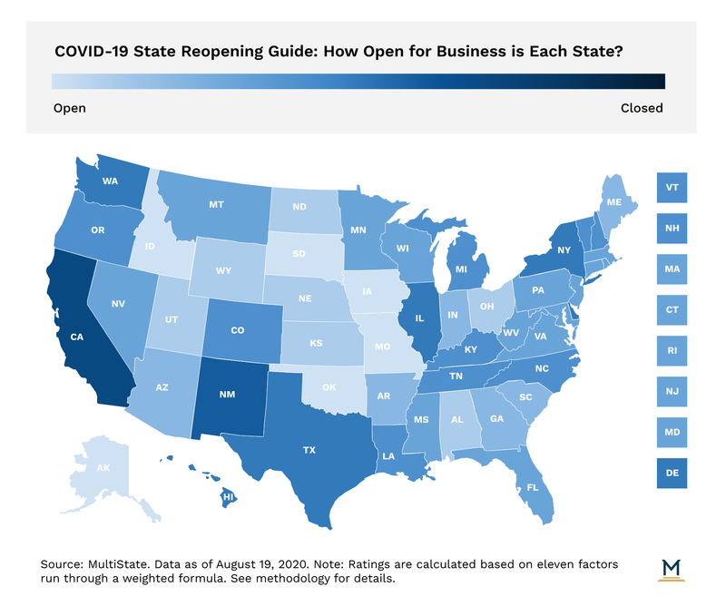

Supporting Question: 1. How did states responds with their Openness?

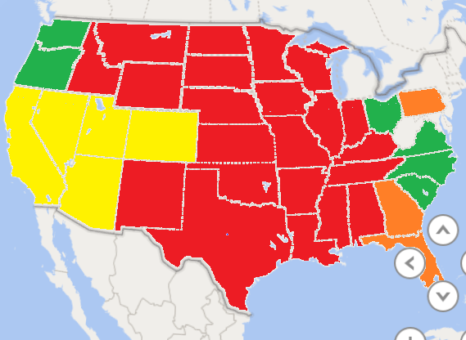

Supporting Question: 3. How did states Anxiety levels change throughout COVID?

Johns Hopkins Anxiety Chart

NOW FOR THE BIG REVEAL – COMBINING THEM ALL

Primary Hypothesis: States with more restrictive lockdown measures experienced higher levels of anxiety and depression.

* Null: Did states with more restrictive lockdown measures experienced higher levels of anxiety and depression? If no, then accept NULL hypothesis – which means there is no significant relationship. Based on P-Value > 0.05
* Alternative: If yes, then deny NULL hypothesis – which means there is a significant relationship. Based on P-Value P-Value =< 0.05

Variable 1 Openness

1. Multistate

Variable 2 Anxiety and Depression

1. Anxiety and Depression vs Baseline
2. Covid Cases by State

Key for all 3 data sets will be the State Columns

* For **Multistate** = “Jurisdiction” with states in this format: Alabama
* For **Anxiety and Depression vs Baseline (CDC)** = “State” with states in this format: Alabama
  + For Baseline, we will look at CDC anxiety and depression levels in the first week vs current.
* For **Covid Cases by State** (John Hopkins) = “state” with states in this format: Alabama

Chart:

Scatter plot with x axis = Covid cases by state per 100K, y axis = Openness, weight = anxiety and depression

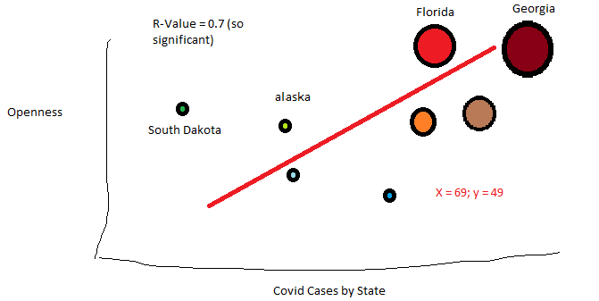

Scatter bubble weight = Anxiety and Depression levels.

**Research Data and Description**

Johns Hopkins COVID-19 Case Tracker:

[URL](https://data.world/associatedpress/johns-hopkins-coronavirus-case-tracker/workspace/file?filename=3_cases_and_deaths_by_state_timeseries.csv)

[GITHUB Link](https://github.com/CSSEGISandData/COVID-19)

Team Awesome Folder

Data type: API

Caveats: Cases may reflect the availability of tests and ability to turn around tests quickly – NOT actual disease spread or infection rates.

*Note, there are many data files, but they all seem to roll up into 3 main reports. I chose the STATE level of the 3.

Data Dictionary: <https://data.world/associatedpress/johns-hopkins-coronavirus-case-tracker/workspace/data-dictionary>

Relevant File 1: 3_cases_and_deaths_by_state_timeseries.csv

Data Date Range: Jan 22, 2020 to Present (Updated hourly)

df.info: 12 Columns, 11760 Rows, All States (including PR, Samoa, Guam, Marianas, Virgin Islands, DC).



Relevant File 2: State Cases and Deaths 1.22.20 to present Current highest Per Capita

Data Date Range: Jan 22, 2020 to Present (Updated hourly)

df.info: 4 Columns, 11760 Rows, All States (including PR, Samoa, Guam, Marianas, Virgin Islands, DC).

------------------------------------------------0------------------------------------------------

United States Department of Labor – Unemployment Insurance Weekly Claims Data

[URL](https://oui.doleta.gov/unemploy/claims.asp)

Team Awesome Folder

Data type: Website

Relevant File: Unemployment Insurance Weekly Claims Data

Data Date Range: 1967 to Present

Available Data: National or State

National



State by State

[Weekly Pandemic Claims](https://oui.doleta.gov/unemploy/docs/weekly_pandemic_claims.xlsx): starts 4/4/20 for UI Payouts starting the week of 3/28/2020

[other](https://oui.doleta.gov/unemploy/uirelprojects.asp) interesting Unemployment Resources:

[Study of UI Exhaustees](https://wdr.doleta.gov/research/FullText_Documents/ETAOP-2017-12_UI_Exhuastees_Report_%28Accessible_PDF%29.pdf),

[State Trust Fund Exhaustion Report](https://oui.doleta.gov/unemploy/docs/trustFundSolvReport2020.pdf)

Multistate.us/research/covid/public

[URL](https://www.multistate.us/pages/covid-19-policy-tracker)

Team Awesome Folder

Data type: Website

Relevant File 1: COVID-19 State and Local Policy Dashboard

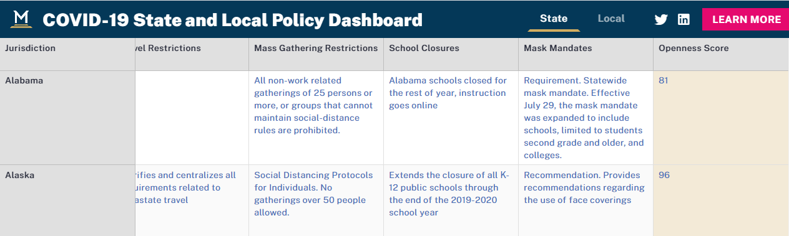

| **Jurisdiction** | **Health Department Website** | **Official Social Media Accounts** | **Key Health Contacts** | **Reopening Plan** | **State of Emergency Declaration** | **Travel Restrictions** | **Mass Gathering Restrictions** | **School Closures** | **Mask Mandates** | **Openness Score** |
| --- | --- | --- | --- | --- | --- | --- | --- | --- | --- | --- |

[State Reopening Map](https://s3.amazonaws.com/multistate.us/production/landingpages/lVuCr7cjjEN5zN11b/body/upload-336757.png)

[Mask Mandates](https://s3.amazonaws.com/multistate.us/production/landingpages/lVuCr7cjjEN5zN11b/body/upload-a01d84.png)

[Travel Restrictions](https://s3.amazonaws.com/multistate.us/production/landingpages/lVuCr7cjjEN5zN11b/body/upload-924f8c.png)

[Essential Business](https://s3.amazonaws.com/multistate.us/production/landingpages/lVuCr7cjjEN5zN11b/body/upload-9db40f.png)

Postman COVID-19 API Tracking project

[URL](http://covidtracking.com/api/us)

Team Awesome Folder

Data type: API

Relevant File 1: [The COVID Tracking Project](http://covidtracking.com/api/us)

[States Current](https://covidtracking.com/api/states)

{"date":20200818,"state":"WI","positive":71424,"negative":1075397,"pending":185,"hospitalizedCurrently":369,"hospitalizedCumulative":5380,"inIcuCurrently":109,"inIcuCumulative":964,"onVentilatorCurrently":null,"onVentilatorCumulative":null,"recovered":57382,"dataQualityGrade":"A+","lastUpdateEt":"8/18/2020

00:00","dateModified":"2020-08-18T00:00:00Z","checkTimeEt":"08/17

20:00","death":1059,"hospitalized":5380,"dateChecked":"2020-08-18T00:00:00Z","totalTestsViral":null,"positiveTestsViral":null,"negativeTestsViral":null,"positiveCasesViral":66830,"deathConfirmed":1052,"deathProbable":7,"totalTestEncountersViral":null,"totalTestsPeopleViral":1142227,"totalTestsAntibody":null,"positiveTestsAntibody":null,"negativeTestsAntibody":null,"totalTestsPeopleAntibody":null,"positiveTestsPeopleAntibody":null,"negativeTestsPeopleAntibody":null,"totalTestsPeopleAntigen":null,"positiveTestsPeopleAntigen":null,"totalTestsAntigen":null,"positiveTestsAntigen":null,"fips":"55","positiveIncrease":709,"negativeIncrease":9357,"total":1147006,"totalTestResults":1146821,"totalTestResultsIncrease":10066,"posNeg":1146821,"deathIncrease":13,"hospitalizedIncrease":53,"hash":"e6052a81c6516ac9799e2fa6666809a9f3aa9bcc","commercialScore":0,"negativeRegularScore":0,"negativeScore":0,"positiveScore":0,"score":0,"grade":""}

[US Current](http://covidtracking.com/api/us)

[{"date":20200818,"states":56,"positive":5457824,"negative":62806109,"pending":4412,"hospitalizedCurrently":43747,"hospitalizedCumulative":351234,"inIcuCurrently":8927,"inIcuCumulative":16123,"onVentilatorCurrently":2468,"onVentilatorCumulative":1695,"recovered":1898159,"dateChecked":"2020-08-18T00:00:00Z","death":163595,"hospitalized":351234,"lastModified":"2020-08-18T00:00:00Z","total":68268345,"totalTestResults":68263933,"posNeg":68263933,"deathIncrease":1195,"hospitalizedIncrease":2273,"negativeIncrease":602356,"positiveIncrease":40458,"totalTestResultsIncrease":642814,"hash":"d29948615260f4efdb0da83bfd29e98c36a2316e"}]

CDC Mental Health Tracker

[URL](https://www.cdc.gov/nchs/covid19/pulse/mental-health.htm)

[API](https://data.cdc.gov/NCHS/Indicators-of-Anxiety-or-Depression-Based-on-Repor/8pt5-q6wp)

Team Awesome Folder

Data type: Website

Relevant File 1: [The COVID Tracking Project](http://covidtracking.com/api/us)

Indicator, Group, State, Subgroup, Week, Week Label, Value, Low CI, High CI, Confidence Interval, Quartile range

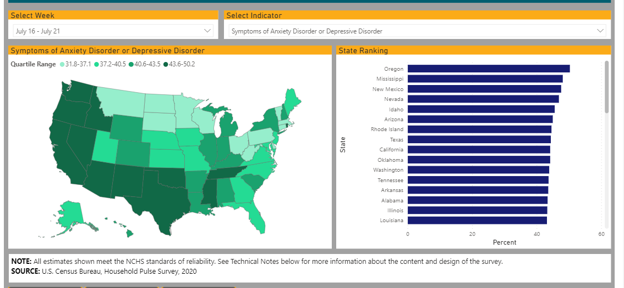

[CDC Anxiety Report](https://data.cdc.gov/NCHS/Indicators-of-Anxiety-or-Depression-Based-on-Repor/8pt5-q6wp)

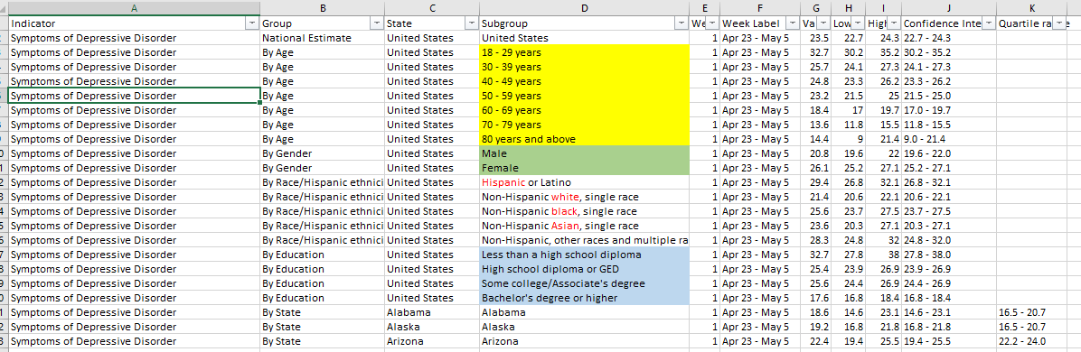

**Project Requirements**

* Development
  + Use Pandas to clean and format
  + Use Jupyter notebook to describe data exploration & cleanup, and deliver final data analysis
  + Use Matplotlib to create 6-8 Visuals (2 per question)
  + Save PNGs of visuals
  + Optional - Use at least one API, if you can find an API with data pertinent to primary question
  + Create a write-up summarizing your major findings. Should include:
    - Heading for each question
      * Description of:
        + Findings
        + Plots
* Presentation
  + Questions we found interesting and motivations to answer them
  + Where and how we found the data we used
  + Feature the Jupyter Notebook data exploration, cleanup & analysis process
  + Deliver conclusions including numerical and visual summaries
  + Implications: What do the findings mean?